Name: _______________________________________________
Foundation Unit 16 topic test
Date:
Time: 40 minutes
Total marks available: 34
Total marks achieved: ______

Questions
Q1.
(a) Simplify c + c + c + c
(1)
(b) Simplify 6 × m × 5
(1)
(c) Simplify 2e × 3f + 7e − 5f
(2)
(d) Expand and simplify (x + 3)(x + 5)
(2)

(Total for question = 6 marks)

Q2.
Expand and simplify (m + 7)(m + 3)
...........................................................
(Total for question = 2 marks)

Q3.
Expand and simplify (x + 3)(x − 1)
...........................................................
(Total for question is 2 marks)

Q4.
(a) Complete the table of values for y = x² – 4
x | −3 | −2 | −1 | 0 | 1 | 2 | 3
y |  | 0 | −3 |  |  | 0 | 5
(2)

(b) On the grid, draw the graph of y = x² – 4 for x = –3 to x = 3

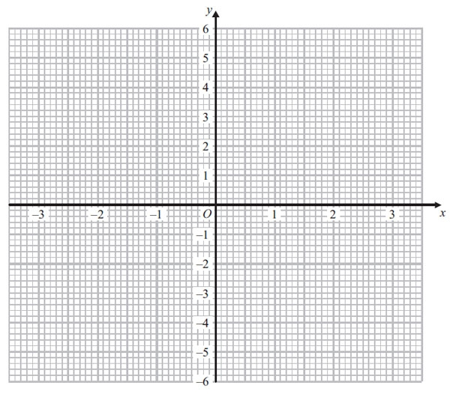
(2)
(Total for Question is 4 marks)

Q5.
(a) Complete the table of values for y = x² − 5x + 3
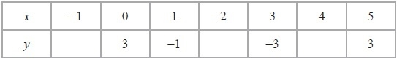
(2)
(b) On the grid below, draw the graph of y = x² − 5x + 3 for values of x from x = −1 to x = 5
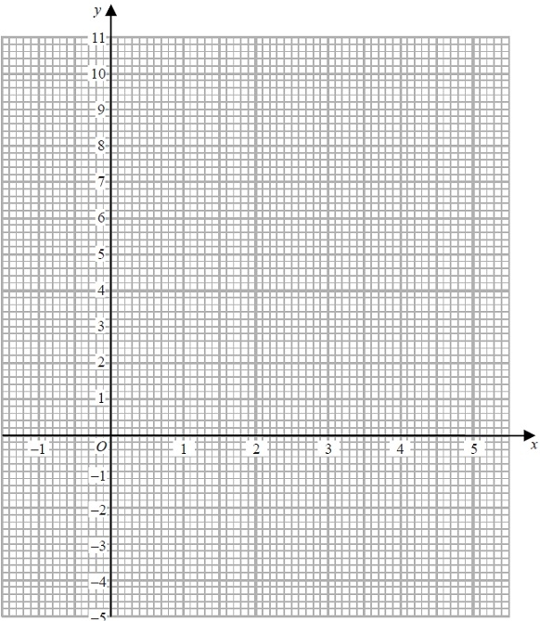
(2)
(c) Find estimates of the solutions of the equation x² − 5x + 3 = 0
x = ...........................................................
or x = ...........................................................
(2)
(Total for Question is 6 marks)

Q6.
(a) Factorise fully 20w²y + 24wy³

..............................................................................................................................................
(2)
(b) Factorise m² + 3m – 40

..............................................................................................................................................
(2)
(Total for Question is 4 marks)

Q7.
Factorise x² + 3x − 4
...........................................................
(Total for question is 2 marks)

Q8.
Factorise x² − 16
...........................................................
(Total for question is 1 mark)

Q9.
(a) Factorise 3f + 9
...........................................................
(1)
(b) Factorise x² − 2x − 15
...........................................................
(2)
(Total for question = 3 marks)

Q10.
(a) (i) Factorise x² – 12x + 27

..............................................................................................................................................
(ii) Solve the equation x² – 12x + 27 = 0

..............................................................................................................................................
(3)
(b) Factorise y² – 100
..............................................................................................................................................
(1)
(Total for Question is 4 marks)
Q1.
No Examiner's Report available for this question

Q2.
No Examiner's Report available for this question

Q3.
No Examiner's Report available for this question

Q4.
Most candidates made good attempts at this final question. A small number of candidates scored one mark for getting at least one value in the table correct but then not plotting at least five of their points correctly. The most common error in completing the table was to write −5 instead of 5 for the value of y when x was −3.
Most candidates were able to plot their points from the table accurately to gain one mark in part (b). Many went on to draw a correct curve to gain the second mark and in some cases recovered from incorrect values in the table.
Around a third of the candidates scored all four marks with many of the candidates who scored three marks either failing to join their correctly plotted points or joining their points with straight lines.
Results Plus: Examiner Tip
Candidates should know that a quadratic expression gives rise to a parabola. In part (a), many calculated the y-value to be −5 when x was −3. This resulted in a curve that was clearly not a parabola. This should have alerted candidates to realise they had made an incorrect calculation.

Q5.
Most candidates scored at least one mark for their attempts to complete the table of values in part (a).
(−1. 7) was the most common error but full marks were still available in part (b) for accurate plotting and drawing of a smooth quadratic curve. Unfortunately many failed to secure both marks in part (b), usually through drawing a line segment between the points (2, −3) and (3, −3). Some candidates were very lazy in their curve drawing and many curves did not pass through their plotted points accurately enough. In part (c), many candidates chose not to use their graph and solved the quadratic equation by an alternative method. Although the correct solutions here did gain full marks, many made mistakes in the application of their method. It should be noted that for those candidates whose graph was more of a cubic form, ALL solutions (if not fully correct) were required.

Q6.
Candidates found part (a) quite challenging. There were a variety of partially factorised answers were given along with some which had correctly identified the 4wy factor but incorrectly dealt one of the terms inside the bracket. In both these cases a single mark was awarded.
In part (b) the incorrect answer m(m + 3) + 40 was often seen. A few used 2 pairs of brackets but the wrong factor pair, typically 4 and 10 but a mark was awarded where the only error was with signs giving (m-8)(m+5). Candidates could be encouraged to multiply out their brackets as a final check – there was little evidence of this taking place.

Q7.
No Examiner's Report available for this question

Q8.
No Examiner's Report available for this question

Q9.
No Examiner's Report available for this question

Q10.
It was disappointing to see that less than a quarter of candidates could factorise a three-term quadratic expression correctly and then solve the associated quadratic equation. However, some managed to factorise correctly and about the same number were able to give a solution where the 3 and 9 in the factors had the incorrect signs.
A surprising number of candidates did not realise that part (ii) followed on from part (i) and gave a solution involving the quadratic formula. In part (b) only a quarter of candidates were able to correctly factorise a quadratic expression where the terms were the difference of two squares (a popular question to include on a Higher Tier paper).

Mark Scheme
Q1.
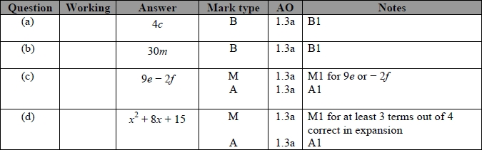

Q2.
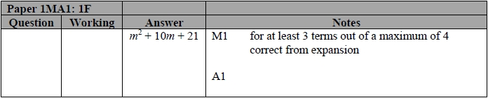

Q3.
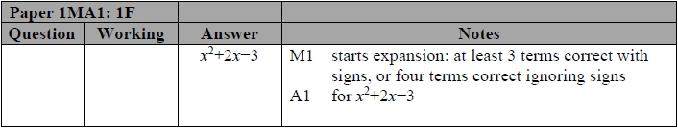

Q4.
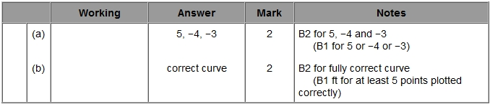

Q5.
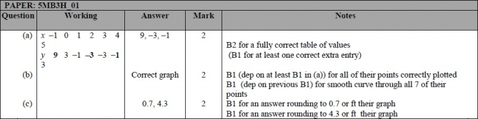

Q6.
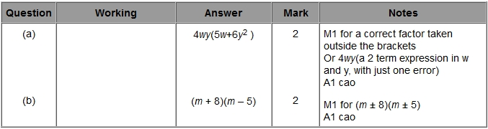

Q7.
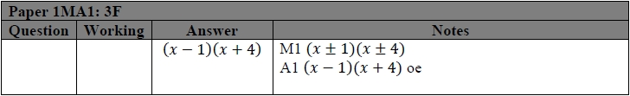

Q8.
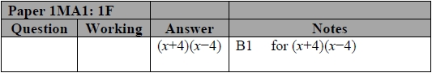

Q9.
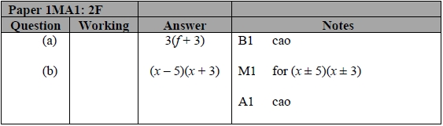

Q10.
